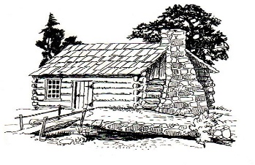
This Photo by Unknown Author is licensed under CC BY-SA
Notice of Meeting
GermANTOWN COLONY MUSEUM
Advisory Board
May 5, 2022
4:30 p.m.
Germantown Colony Museum
120 Museum Road
Minden, la
Meeting is open to the public
Phone: 318-377-6061
P. O. Box 178 Minden, LA 71058

